COLLEGE OF ENGINEERING AND TECHNOLOGY

Name: | MIKAELLA HEART PULIDO
Course/Yr/Section: | BSIT – 2D
Title of Assignment: | Website Development: HEARTIE — Beaded Accessories E-Commerce Platform
Website Development: HEARTIE — Beaded Accessories E-Commerce Platform

Objectives
- Develop a functional e-commerce website for HEARTIE using HTML, CSS, and JavaScript.
- Create a responsive, user-friendly interface with organized navigation.
- Implement interactive features like menu switching, sidebar toggle, and cart alerts.
- Follow proper web development standards and document the complete process.
Description of the Output
A complete e-commerce website for handmade beaded accessories. It has a collapsible sidebar with Home, Products, Categories, Cart, Orders, Wishlist, Profile, Settings, and Logout. Content changes dynamically without page reload. Features active menu highlighting, glass-morphism design, animated borders, and responsive layout for all devices.
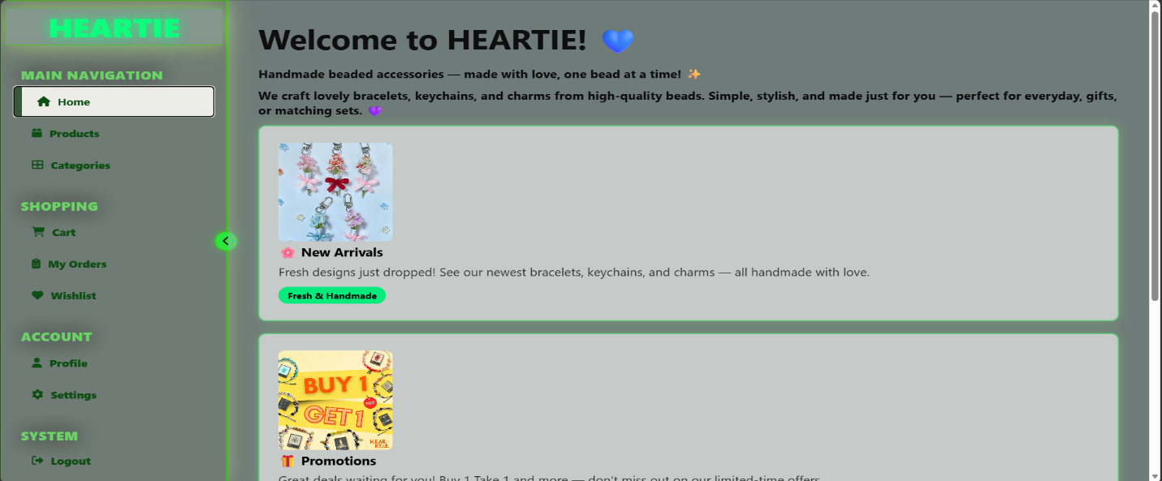
Screenshot of each page or menu output.
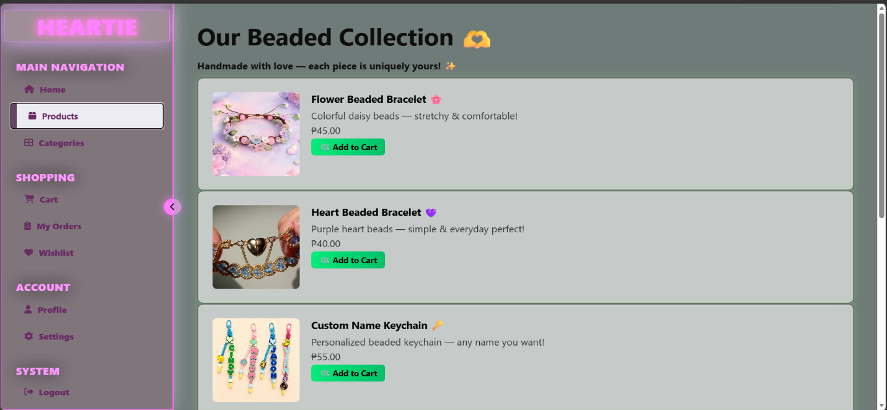
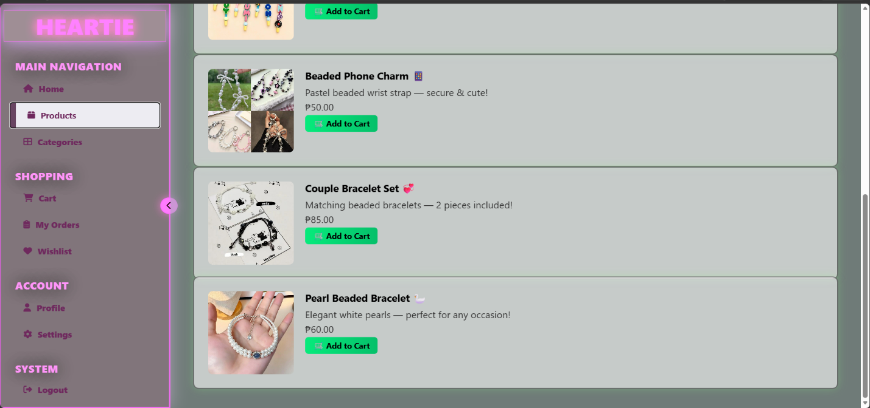
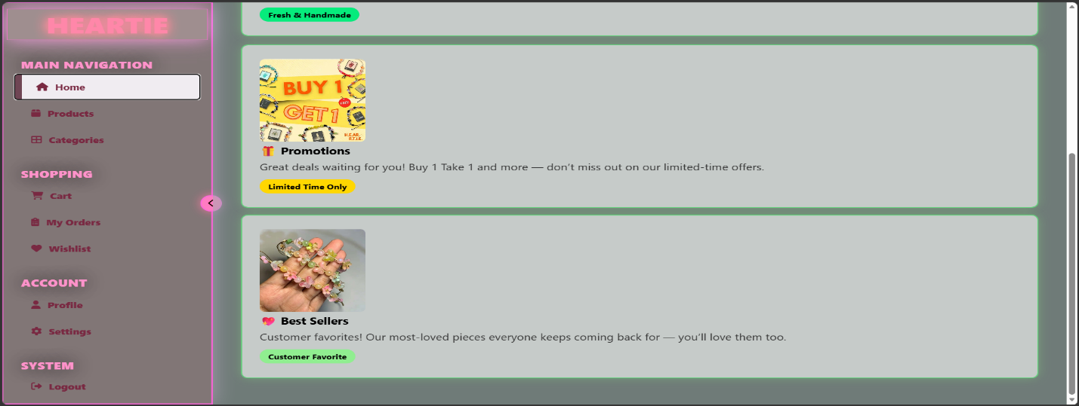
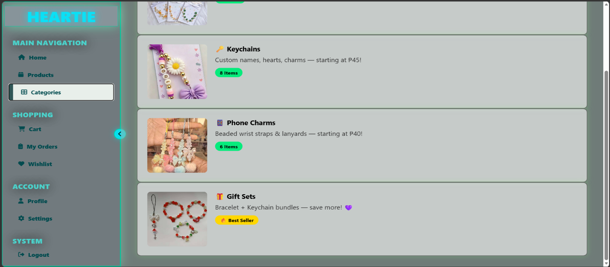
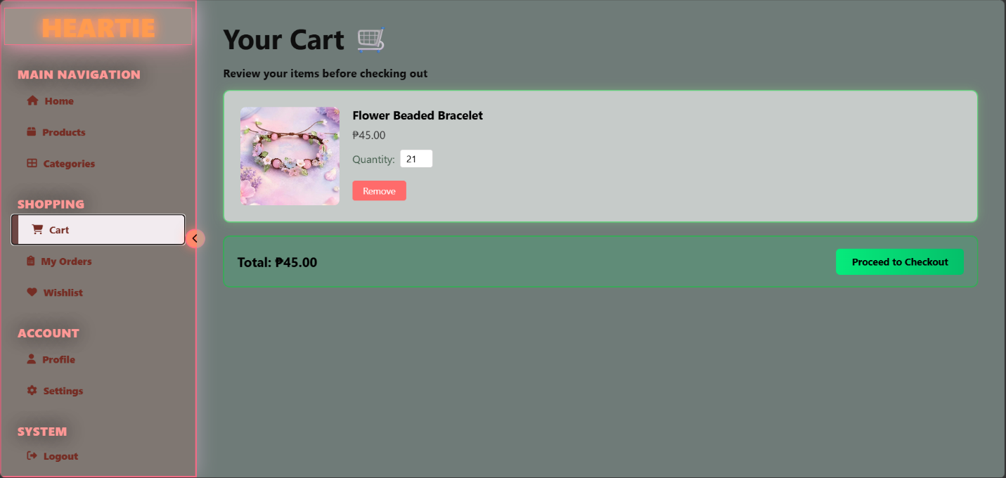
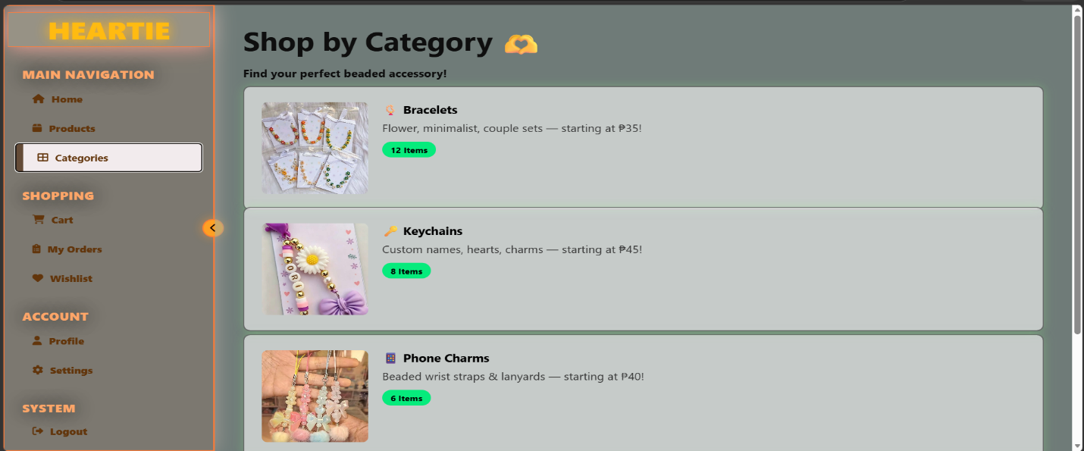
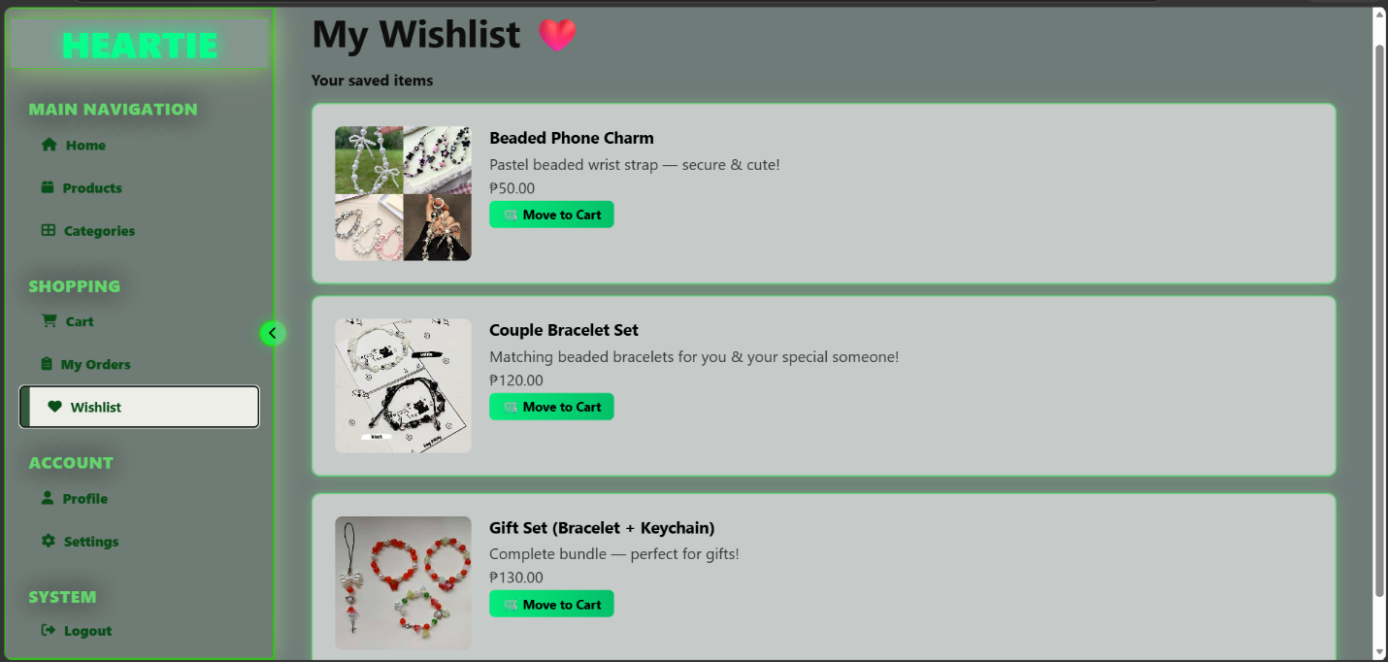
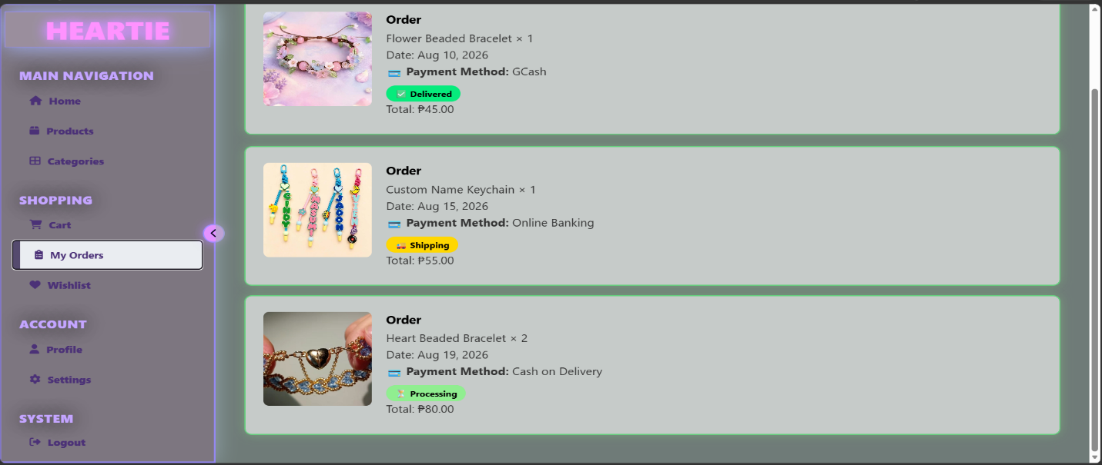
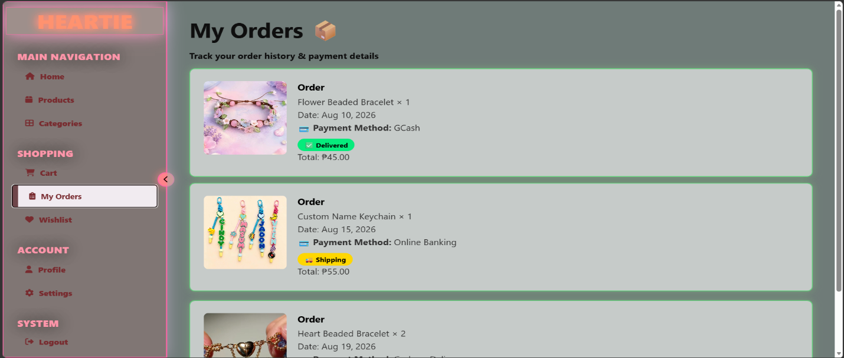
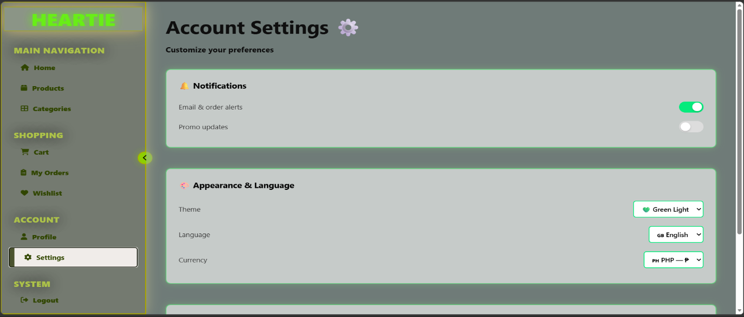
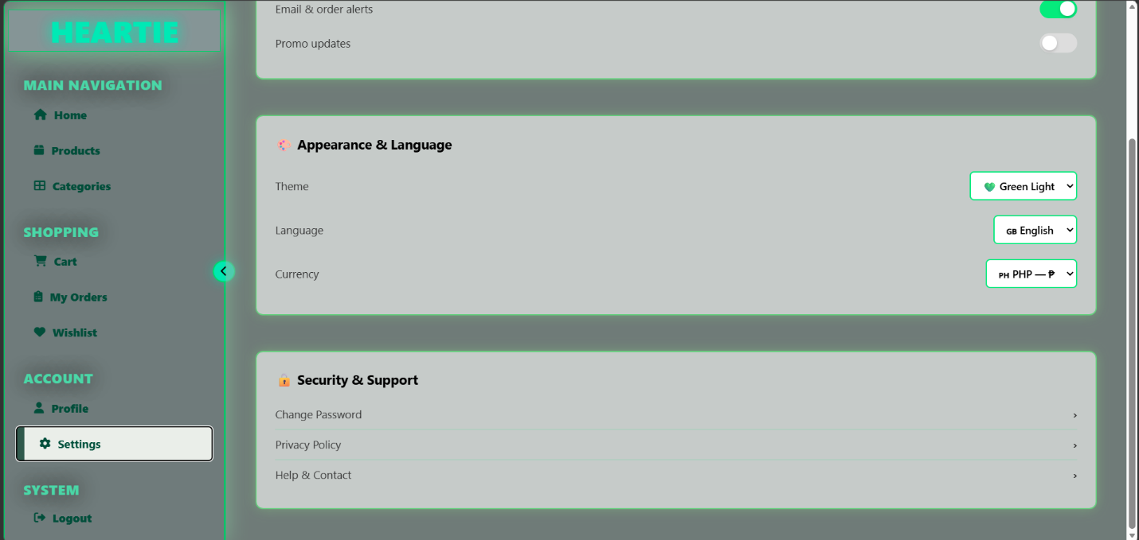
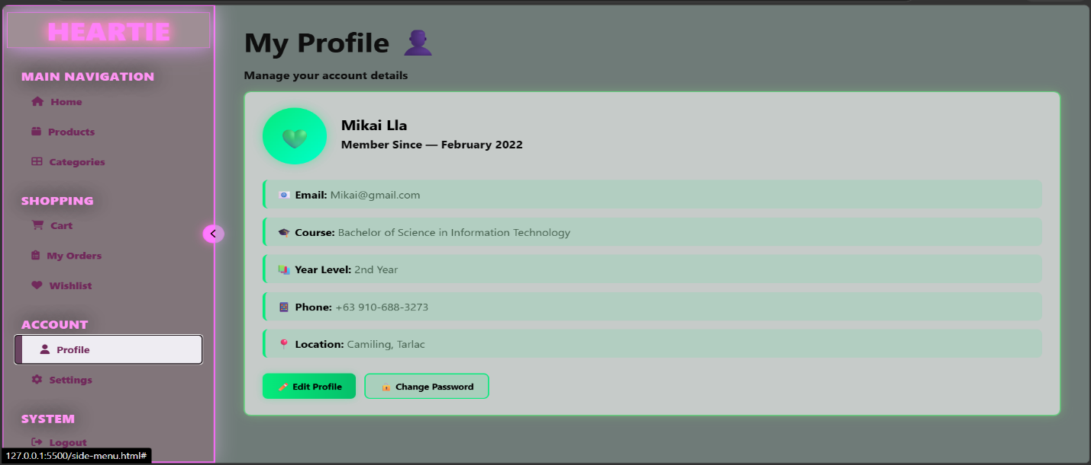
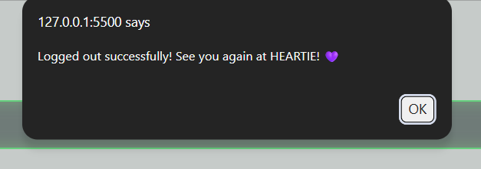
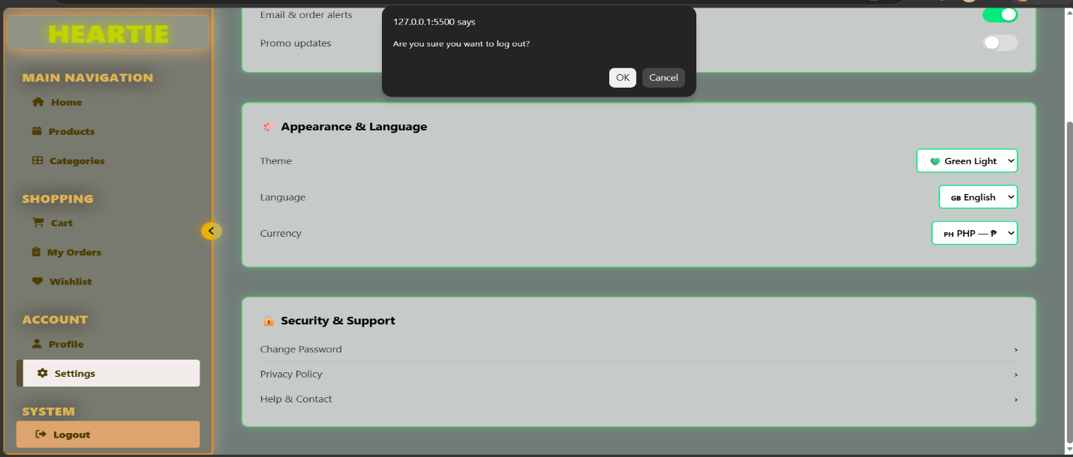

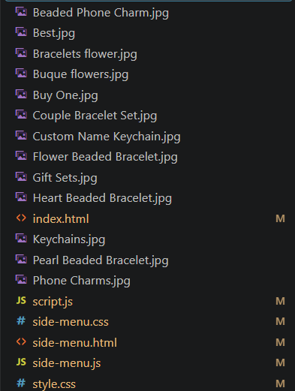
Screenshot of the folder structure

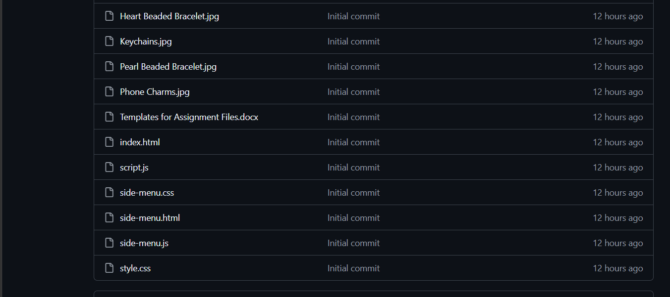
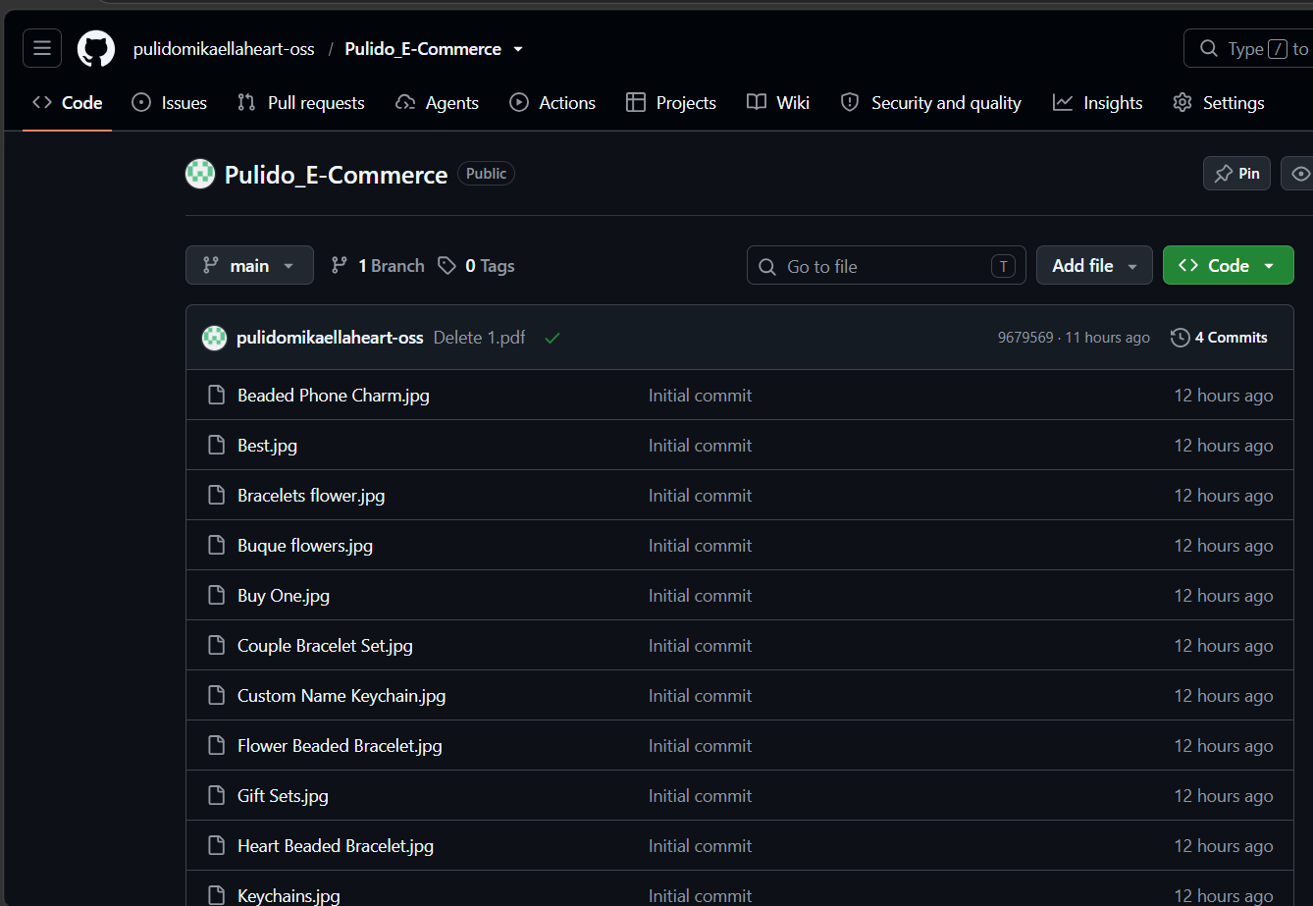
Screenshot of the GitHub repository

Short Explanation of the HTML Structure
HTML forms the skeleton of the site. It has two main parts: a fixed sidebar for navigation and a main content area with separate sections for each page. Each menu item and content section has matching IDs so JavaScript can connect them. External CSS, icons, and JavaScript are linked for styling and interactivity.

Short Explanation of the CSS Design
CSS controls the layout, colors, and visuals. It uses a green-themed palette with glass-morphism blur effects and glowing animated borders. The sidebar is fixed and collapsible. Hover effects, smooth transitions, and responsive rules ensure the site looks good on both desktop and mobile.
Short Explanation of the JavaScript Features
JavaScript adds interactivity
Menu Switching: Highlights active page and shows only selected content.
Sidebar Toggle: Collapses/expands the sidebar and flips the arrow icon.
Logout Confirmation: Asks before logging out to prevent mistakes.
Add to Cart: Shows confirmation alert when adding items.
Conclusion or Reflection
This project taught me that HTML builds the structure, CSS designs the look, and JavaScript makes it interactive. I learned to plan layouts, organize code, and test every feature. It showed me that a good website is not just about looks it must be easy to use and well-organized. I feel more confident now in building complete websites.

https://github.com/pulidomikaellaheart-oss.github.io/Pulido_E-Commerce/side-menu.html
https://github.com/pulidomikaellaheart-oss/Pulido_E-Commerce

